Bandido 90
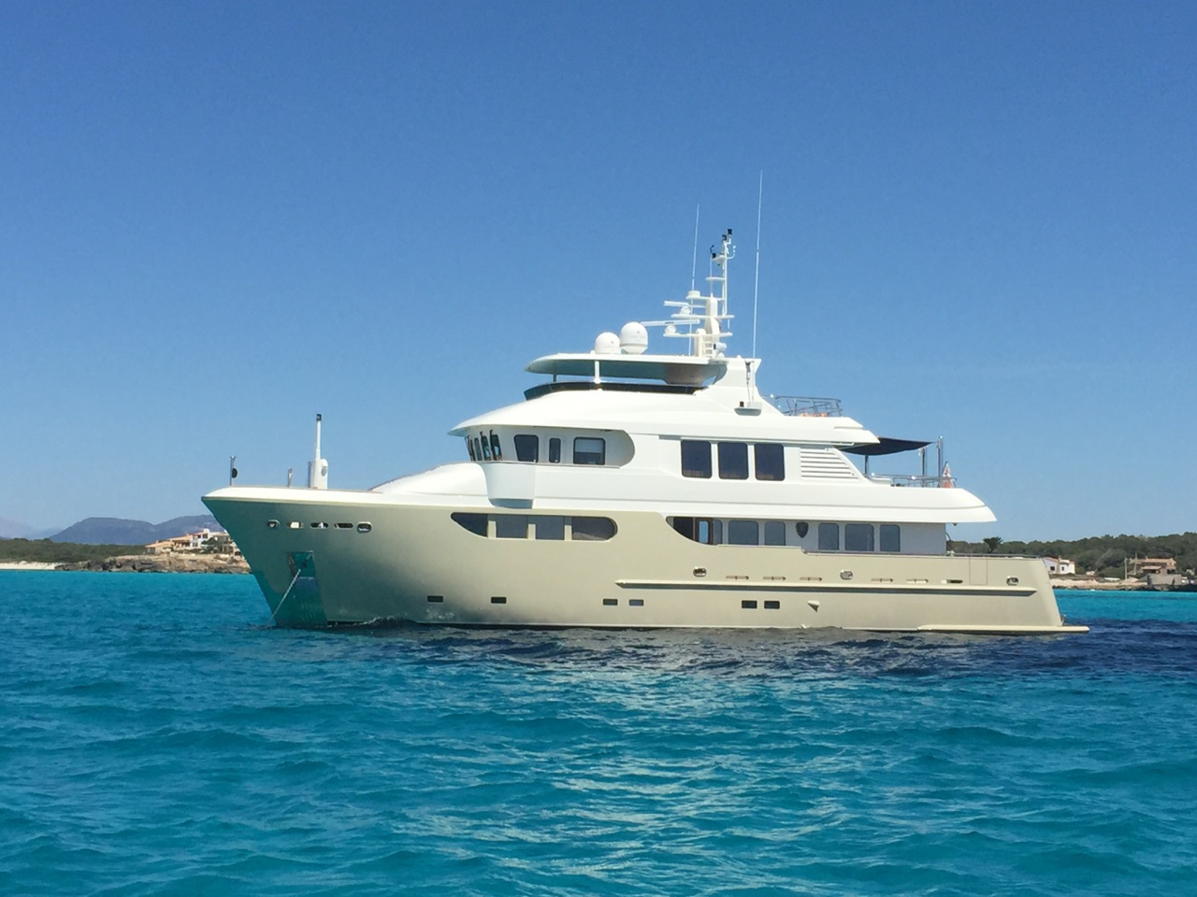

Specification:
Length – 27.90 m.
Beam – 7.65 m.
Draft – 2.40 m.
Engines – 2 x MAN D2842 LE 410, 1100 hp
Engine hours – 1500
Fuel Tanks – 35000 l.
Fresh Water Tanks – 8000 l.
Cabins – 4
Material hull – Steel
Material superstructure – Aluminum
Year of construction – 2010
Price – 3 750 000 EUR
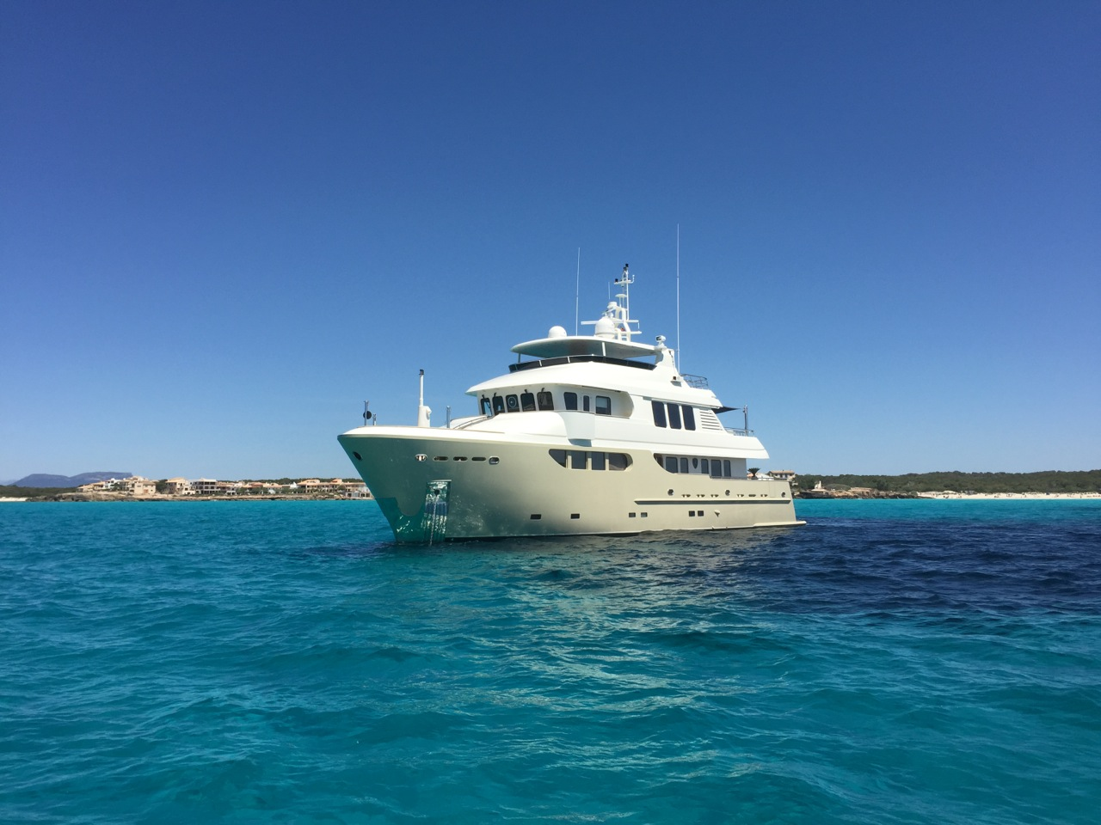
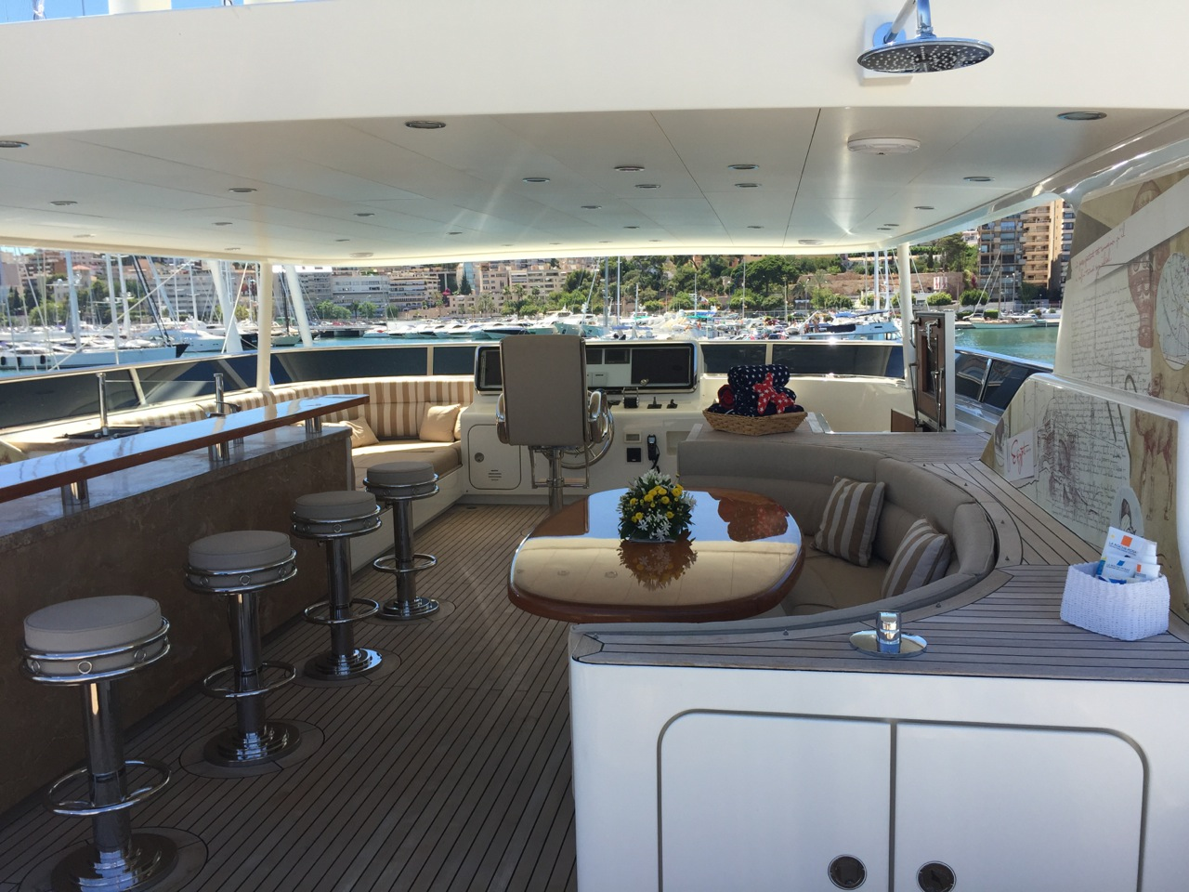
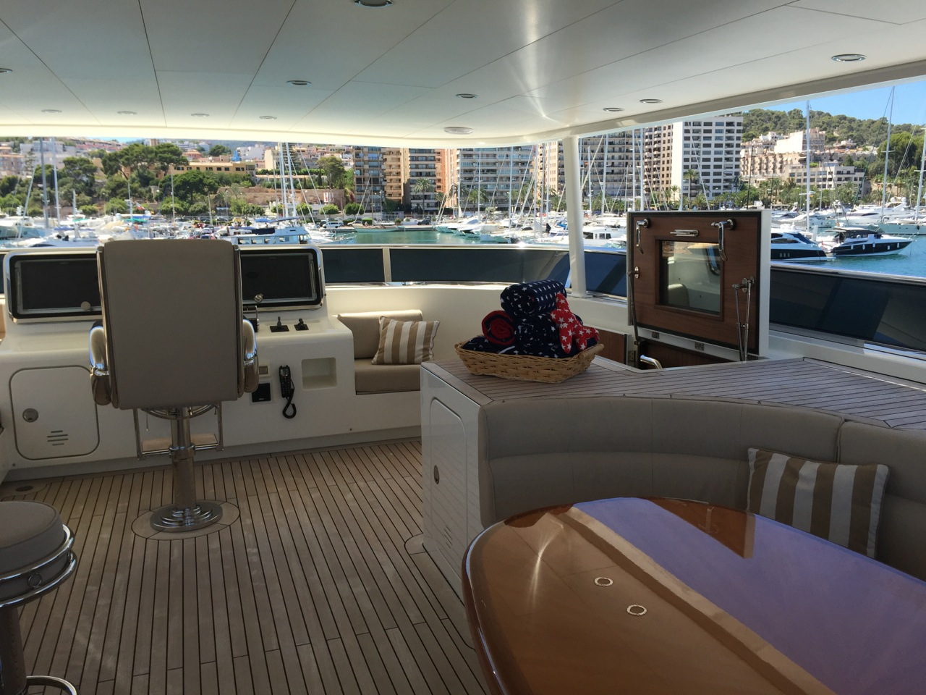
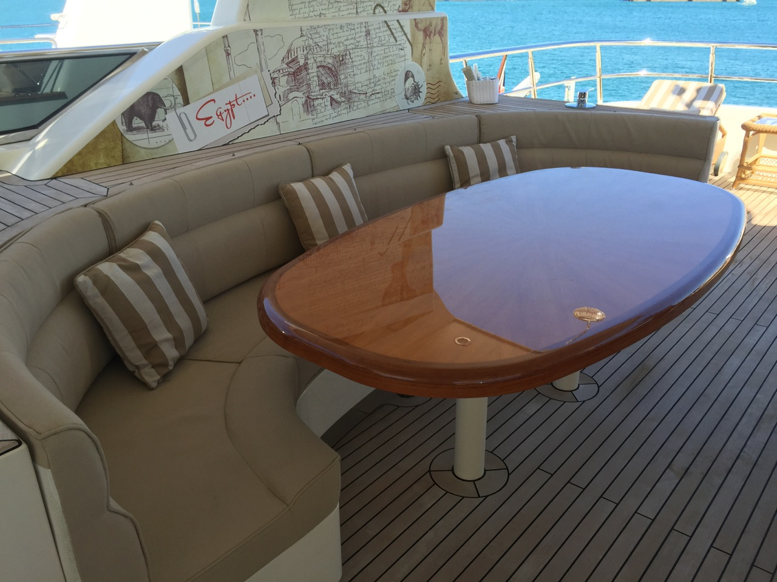
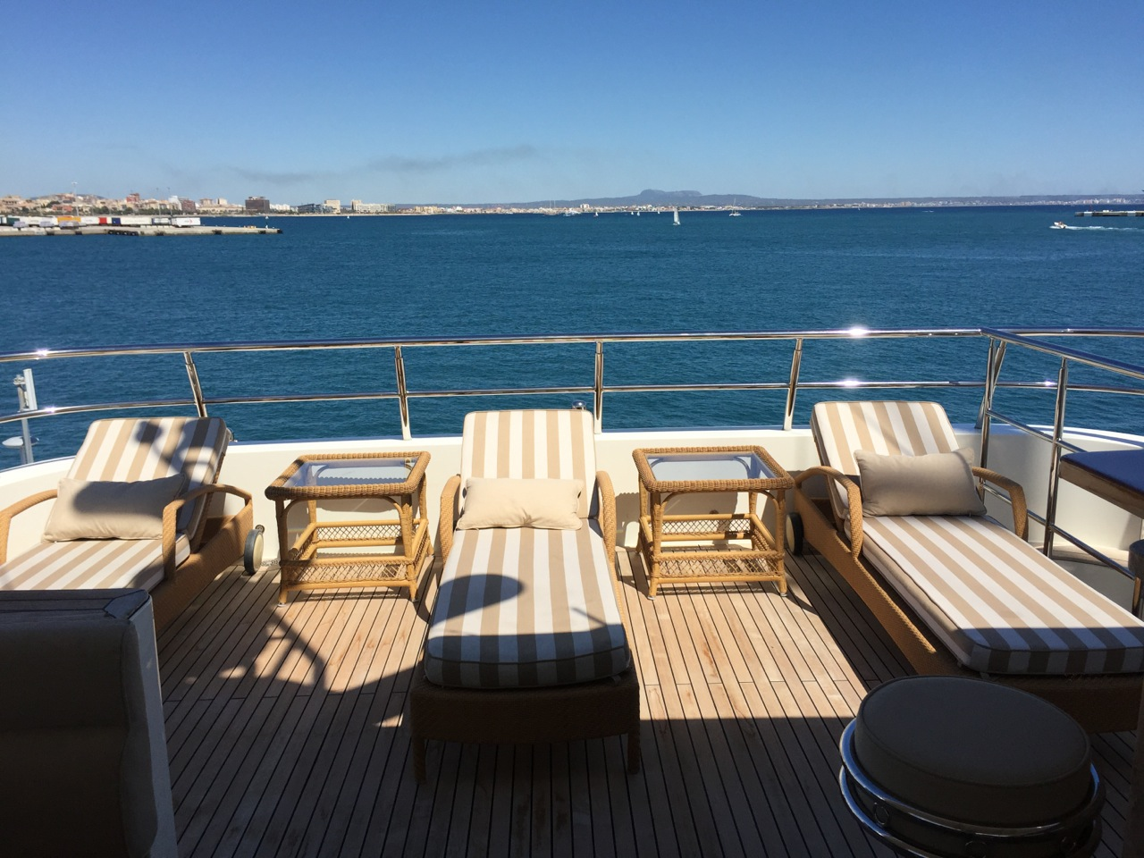
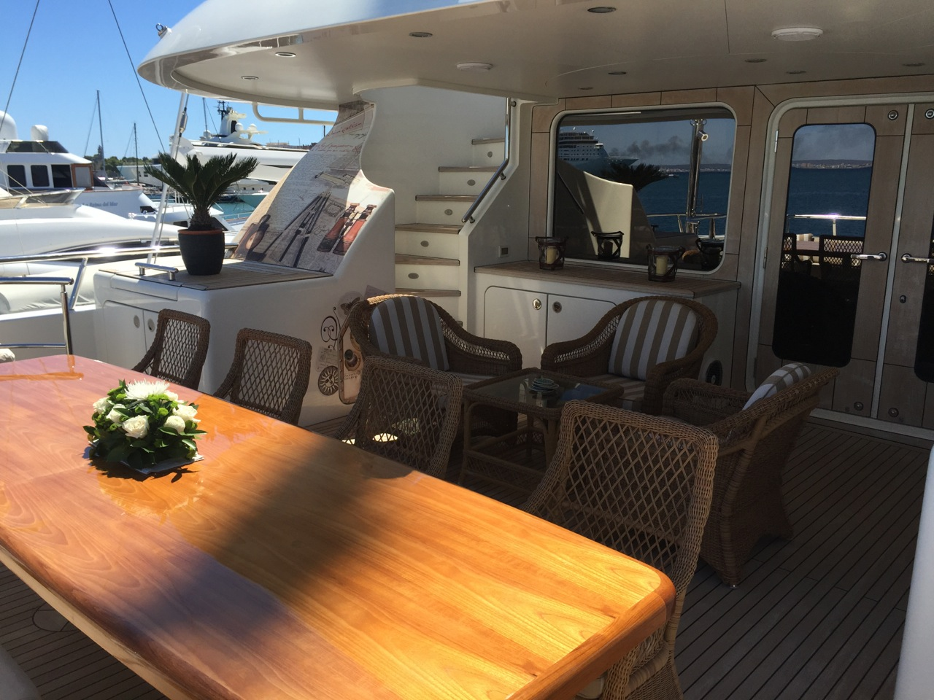
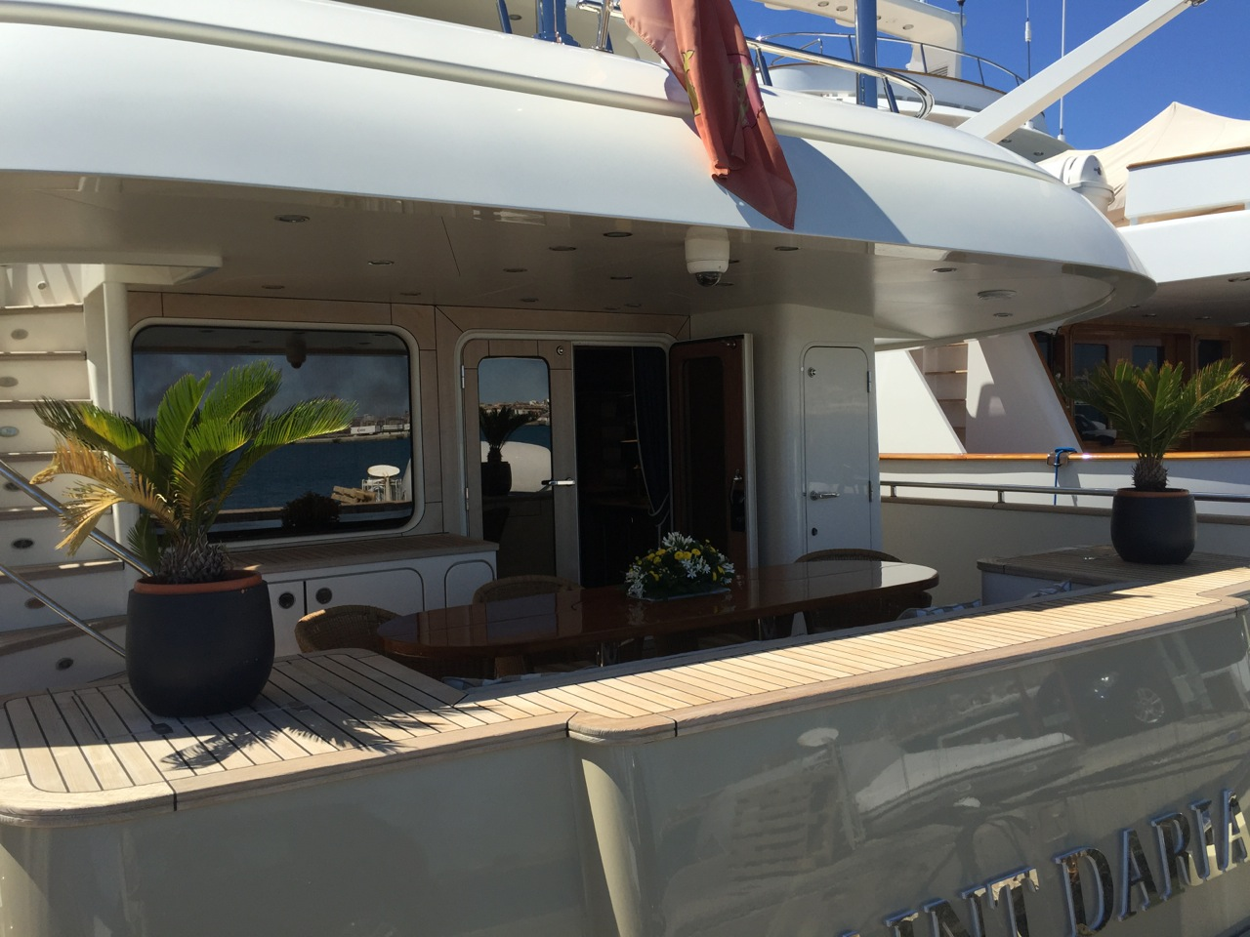
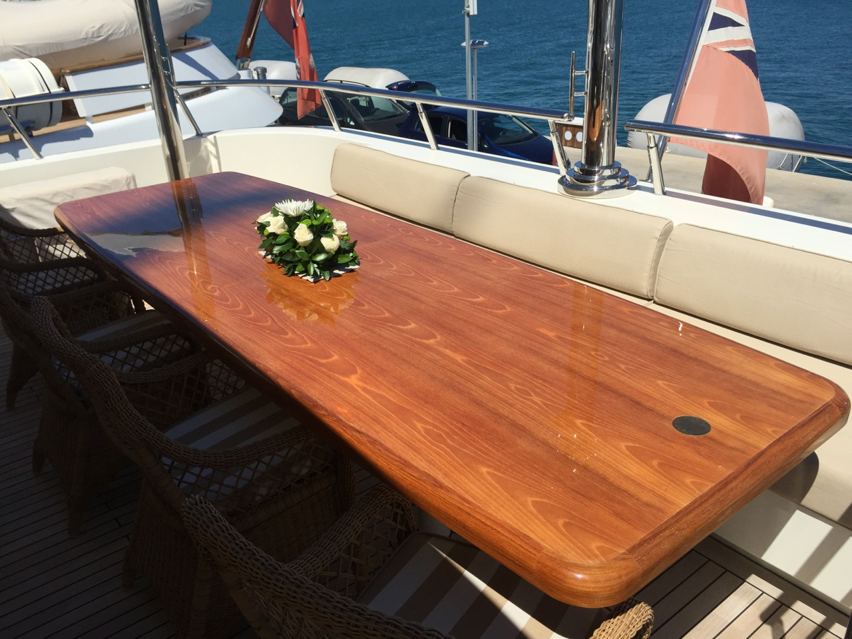
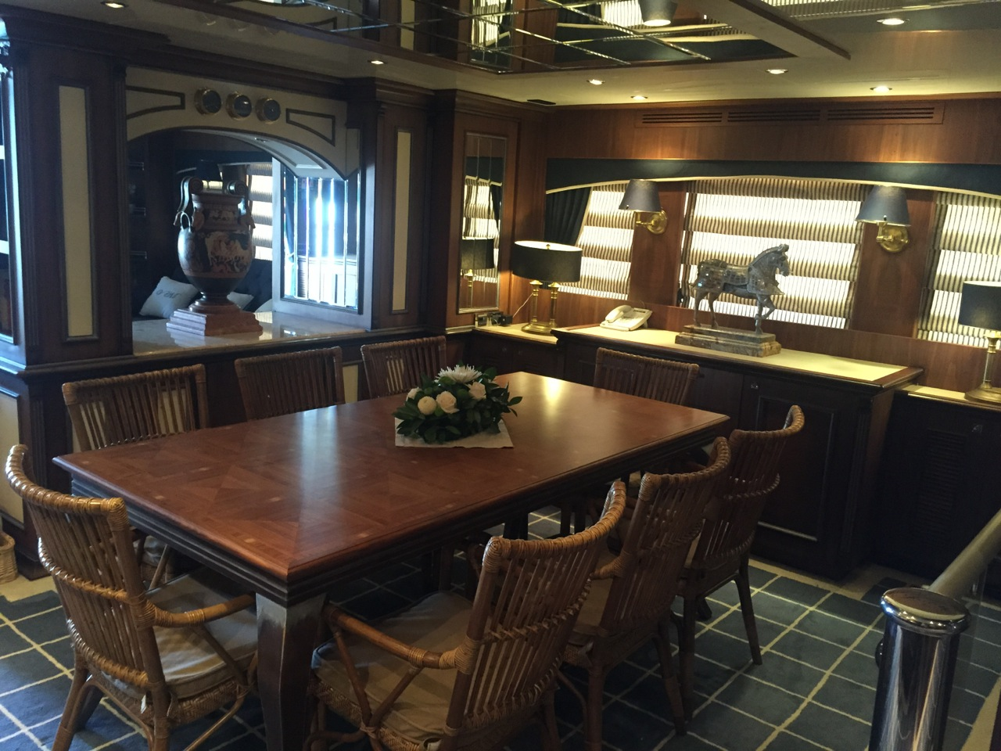
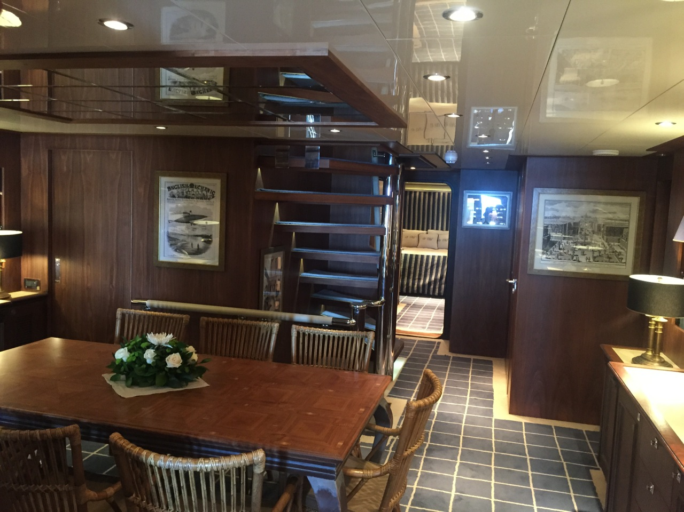
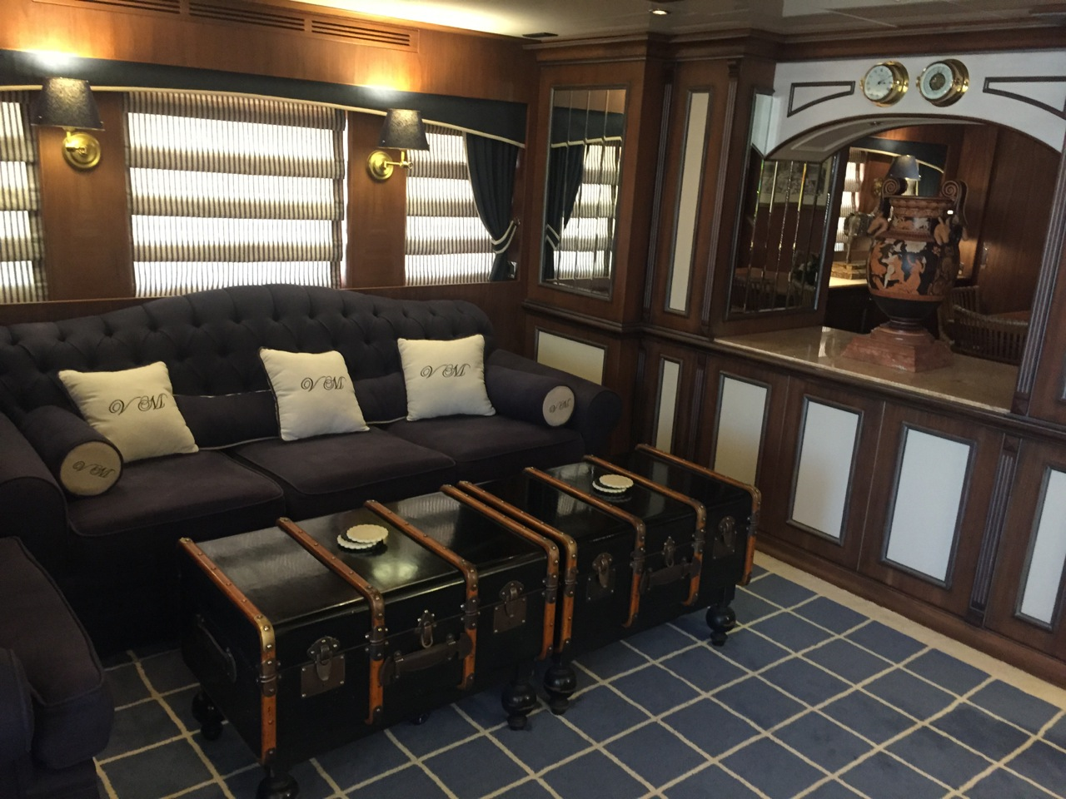
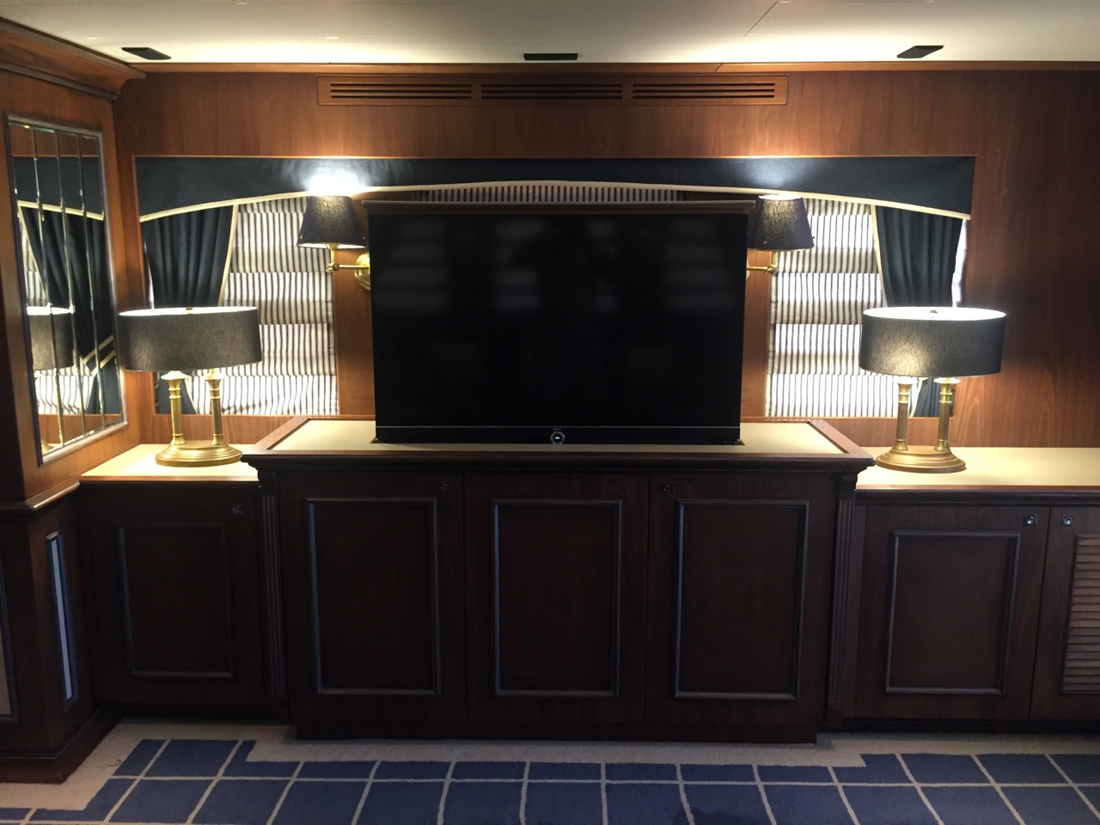
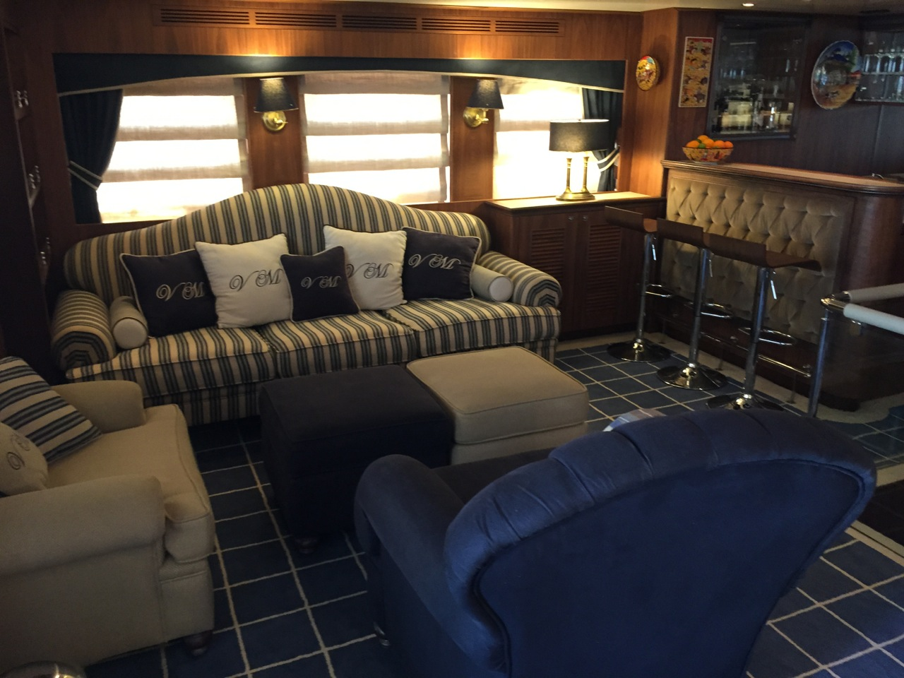
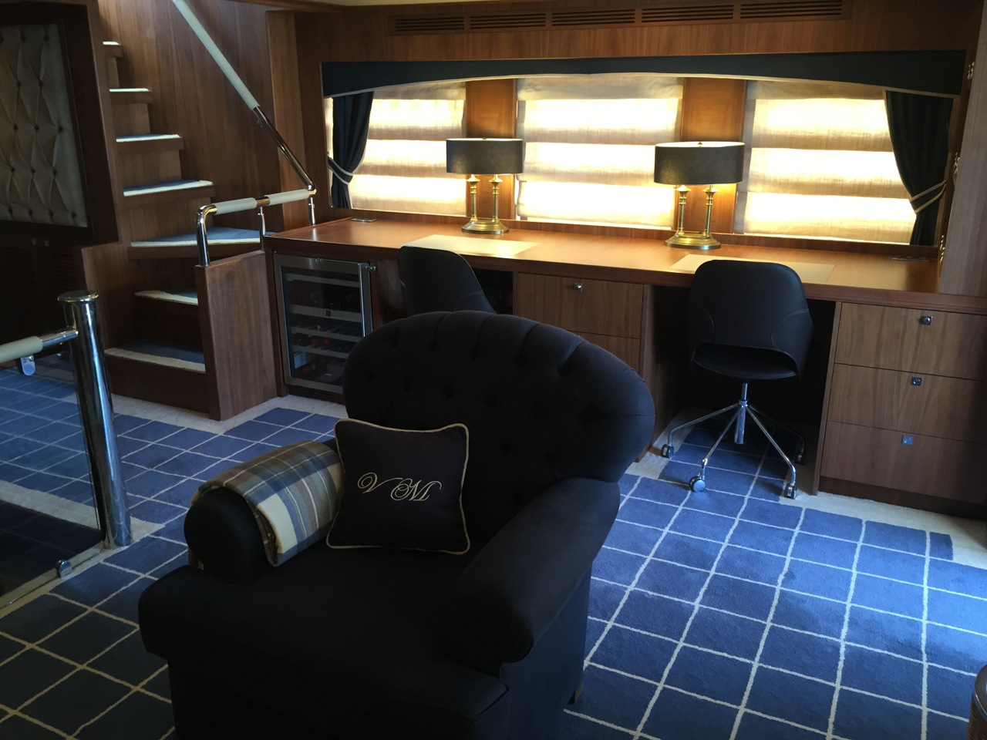
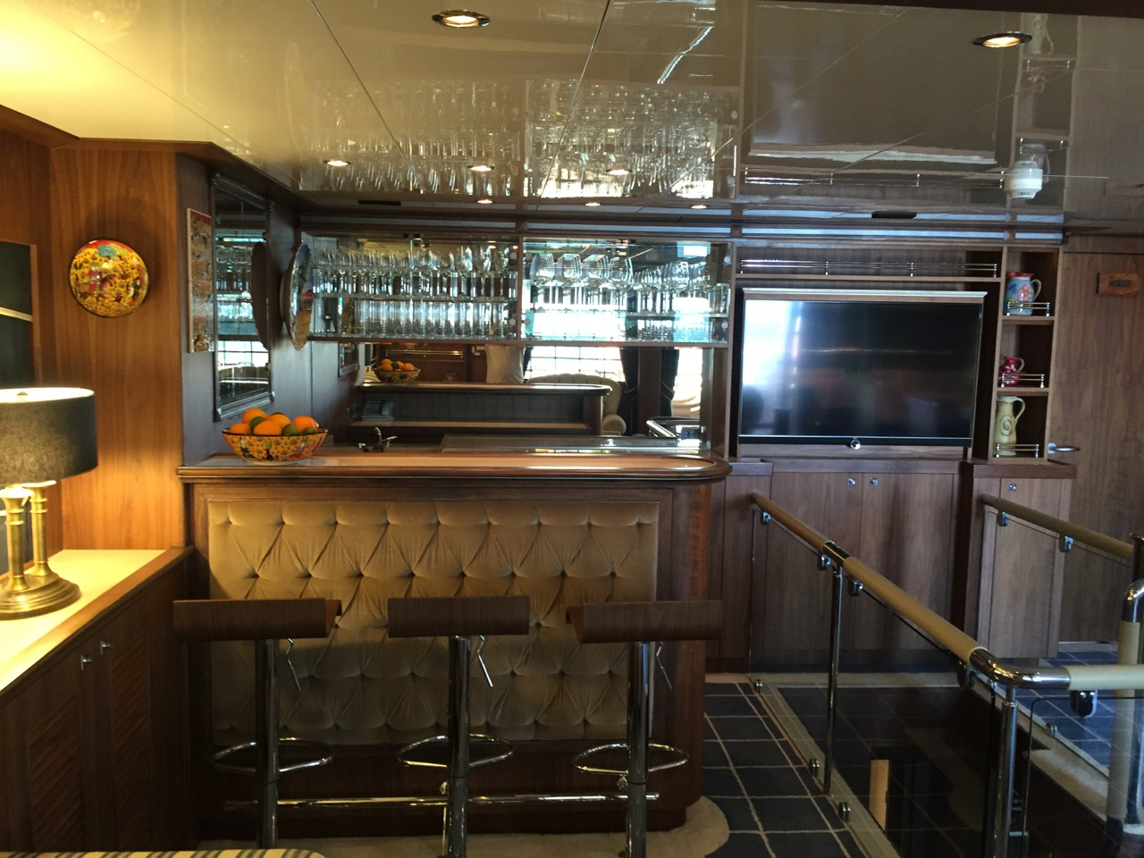
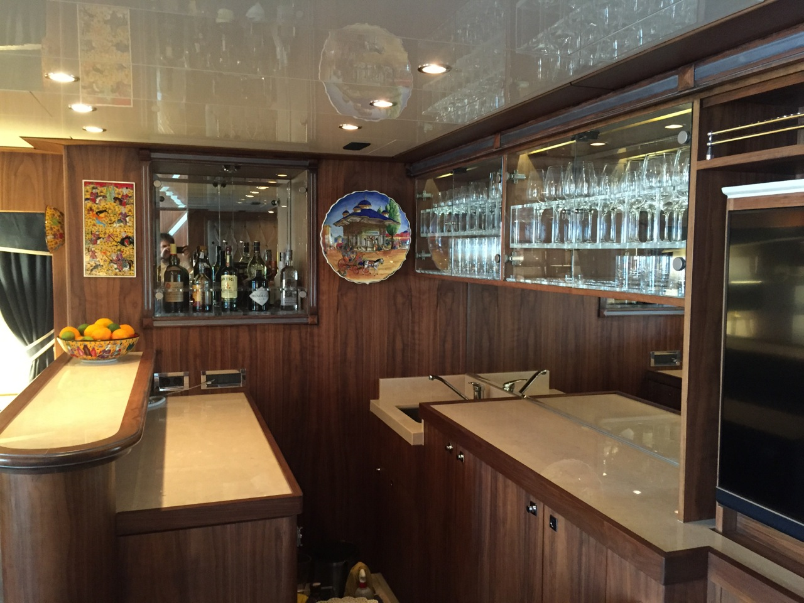
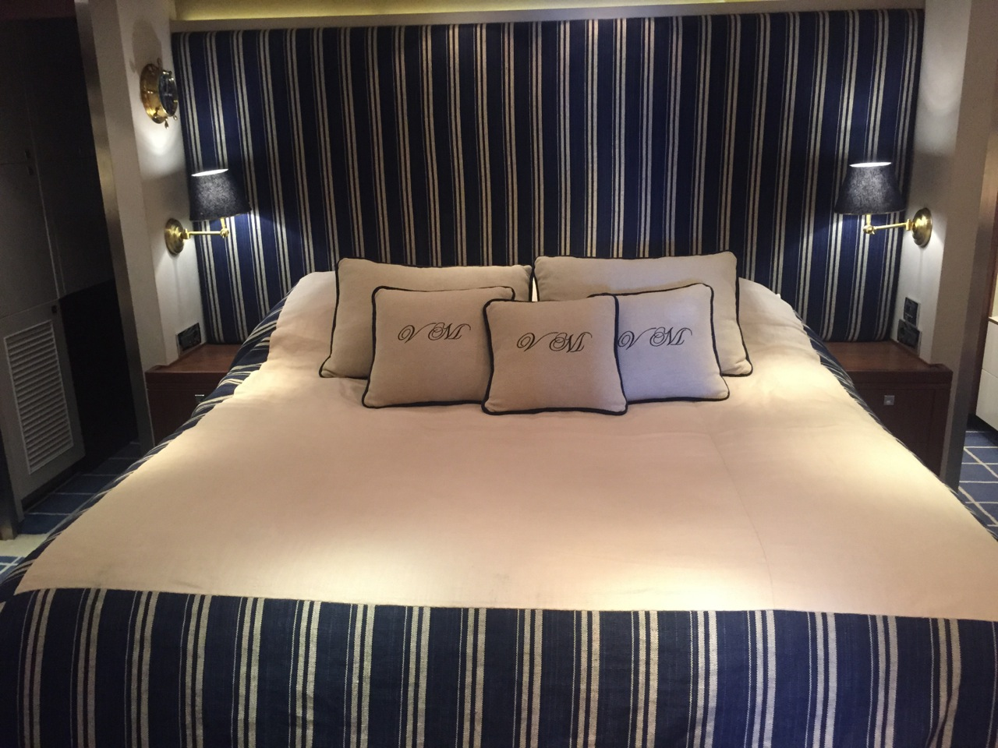
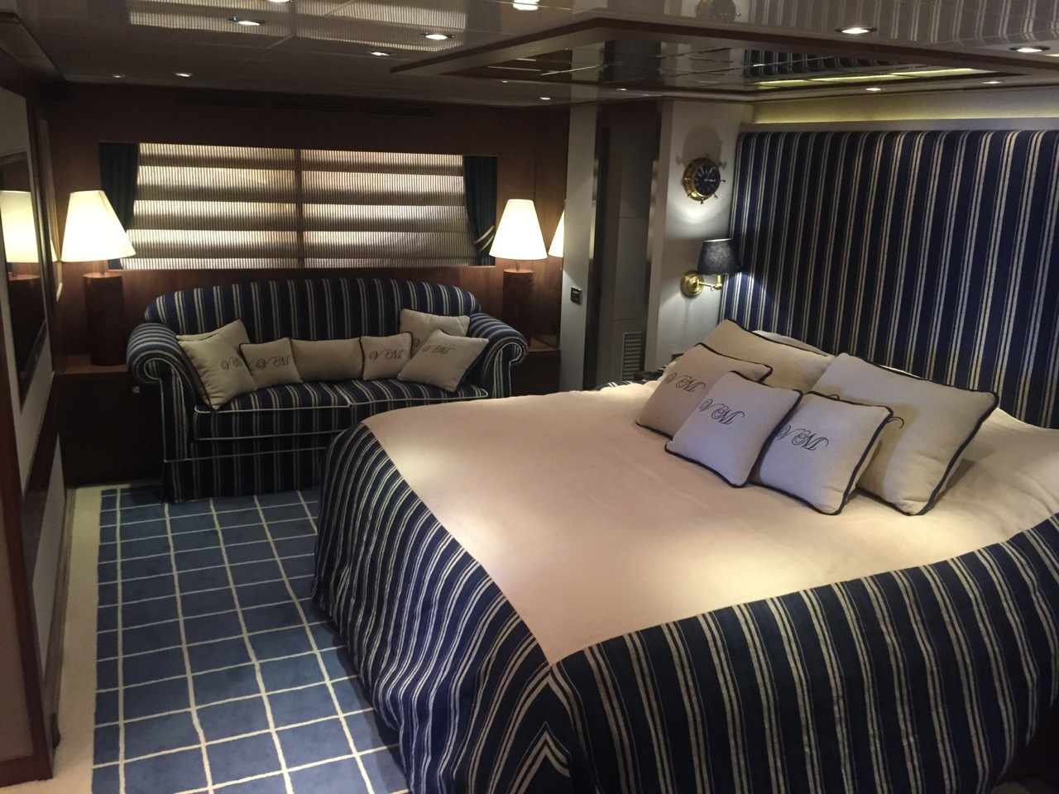
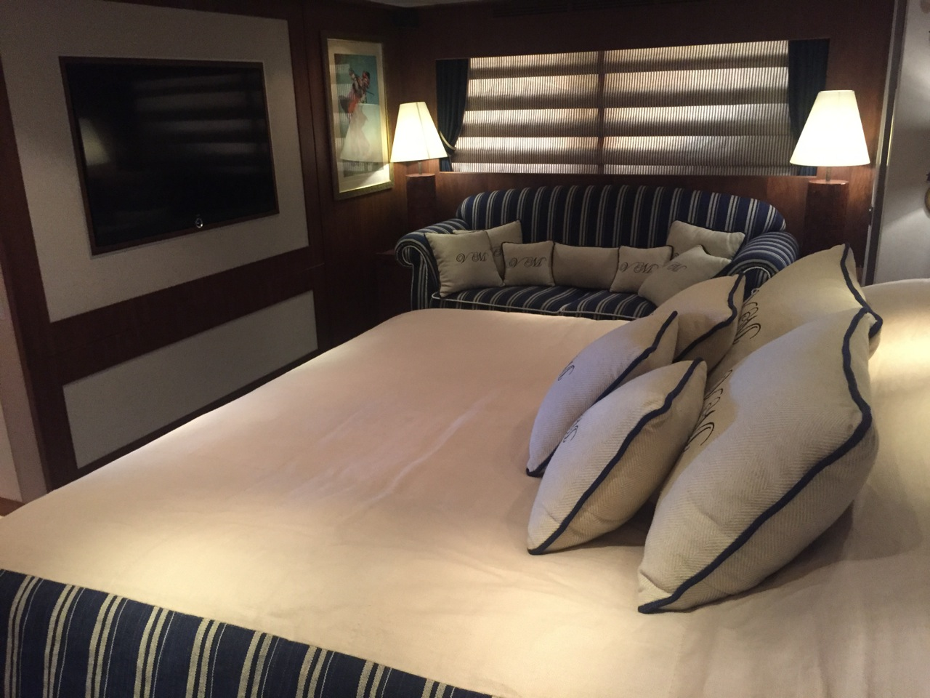
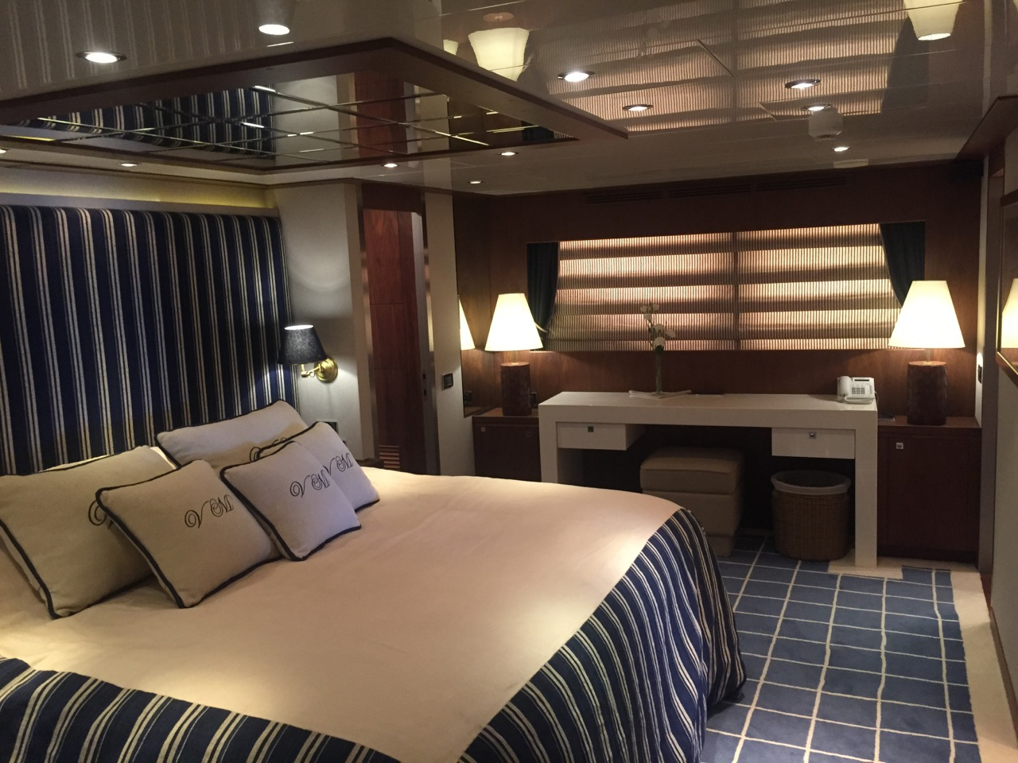
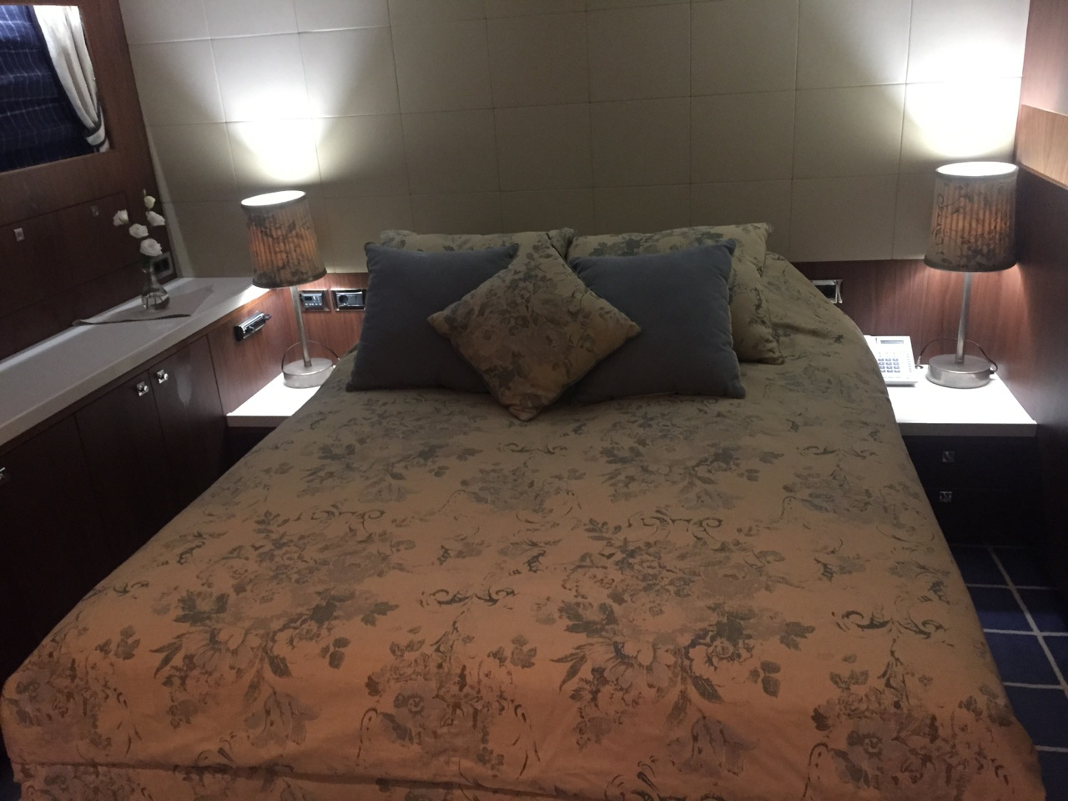
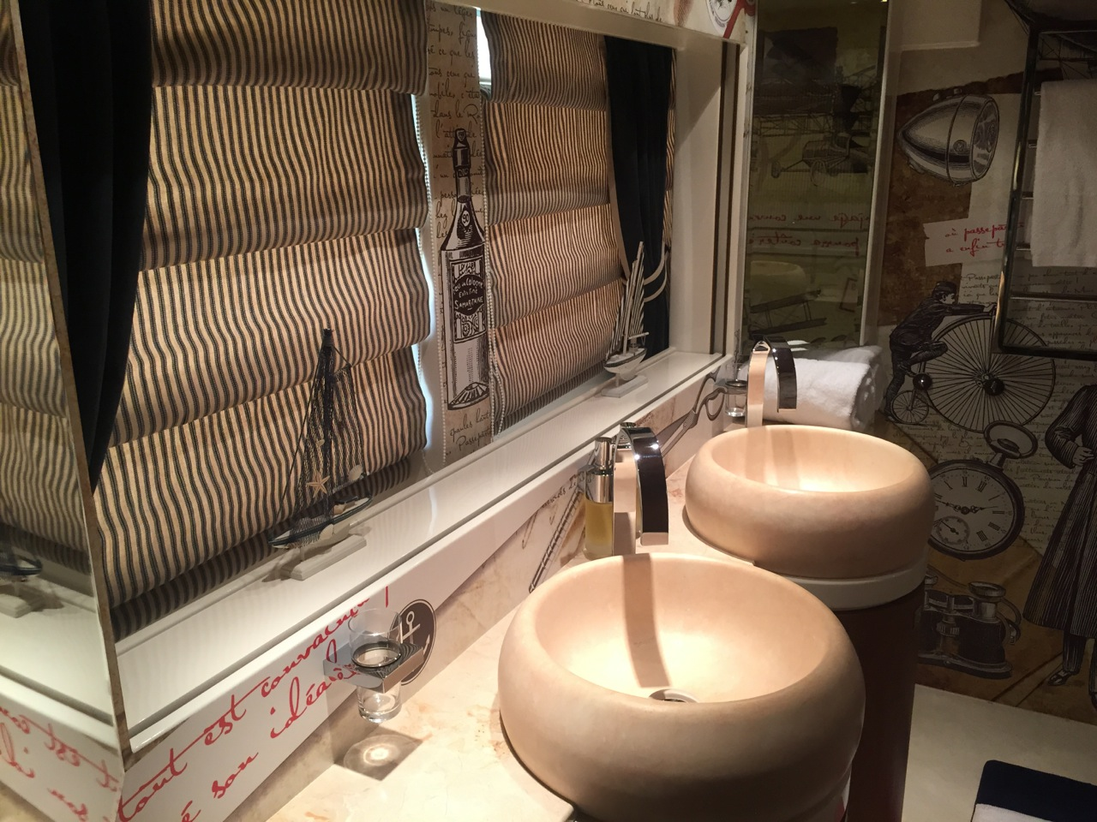
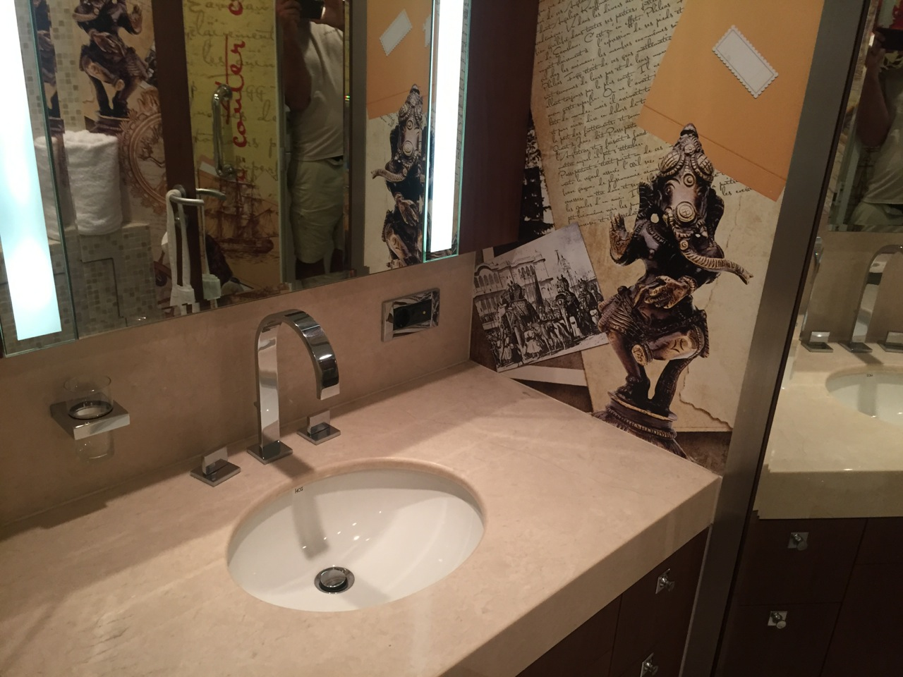
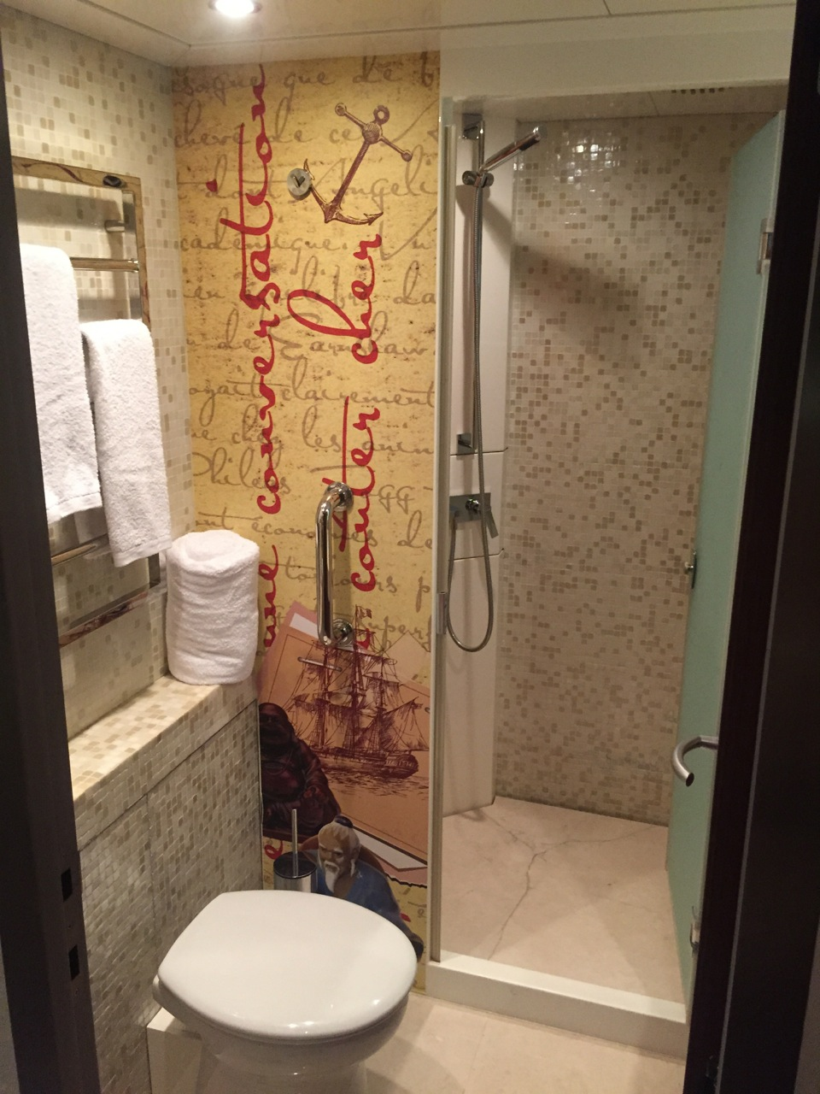
- Engine Controls
- Power Supply
- Cathodic Protection System
- Fire System
- Bilge Pump System
- Black Water System
- Grey Tank System
- Fuel System
- Water Maker
- Ballast Tank System
- Hydraulic System
- Steering System
- Stabilising System
- Thruster System
- Mast on Fore Ship
- PH Helm Chairs
- Anchor & Windlass System
- Teak Decking Etc.
- Tender
- Liferafts
- Lifejackets
- Bridge Wings
- Air Conditioning System
- Central heating System
- Underfloor Heating (El)
- Wall Heating
- Camera System
- Central Vacuum Cleaner
- Charging & Batteries
- Telephone System
- Underwater Lights
- Galley Equipment
- Sun Protection
- Special Equipment
- Boning Monitoring
- Navionics

